**School of Computing Science**

**Pak-Austria Fachhochschule: Institute of Applied Sciences & Technology, Haripur, Pakistan**



# PHY-101L

**Applied Physics Lab**

***Lab Report # 02***

**Submitted By: Haider Nasir**

**Registration #: B24S0308AI08**

**Submitted to:**

**Date of Submission: 03/03/2024**

** School of Computing Science**

**Pak-Austria Fachhochschule: Institute of Applied Sciences and Technology**

**DC Power Sources, Breadboard, Digital Multi-Meter**

**Equipment:**

**1.Power supply**

**2.Connecting wires**

**3.LED**

**4.Breadboard**

**5.Resistor**

**6.Digital Multi-Meter**

**Procedure:**

**.Firstly we have to draw the circuit diagram this is not too much important but to easily understand the concept and to make connection it is very important.** 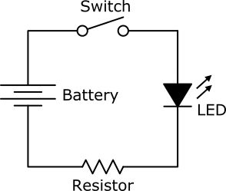

**Fig ; 1.1**

**.By using the breadboard we connect the power supply with the one terminal of the breadboard and the other side of the wire connected to the other terminal this make a polarity of positive and negative at the end of breadboard.We must connect it horizontally.Horizontal and vertical lines shows the wires representation. So in order to complete the circuit we must have the view of the wires and how to connected the bulb and resistor on Breadboard that the circuit become complete and we get the rquired output from it.**

**.Now in order to find the current the voltage and current we must implant the DMM according to our requirement likewise if we want to calculate the current in the circuit we must implant it in series by setting the DMM on the Ammeter and if we want to measure the voltage we turned the DMM to the Voltmeter and we should install it parallel.**

**.Now we measure the DC and AC for voltage and we must put these calculated values on the table no 1.**

**.Now we have to repeat the same step for AC and DC for current.And also for resistance we have to do same.**

**.Now according to the values given in the table no 2 we have to set the knob of the voltage on the supply likewise 2,4,6, and 8 voltage and correspondingly write the voltage we get on the DMM.**

**.We have to take the readings twice or thrice in order to get less chances of uncertainty in readings.**

**.Now we have to find the error in between the supply readings and DMM reading we get the error.**

**ERROR=DMM READINGS-SUPPLY READINGS**

**.Now in order to find the % error we used this**

$$\%Error=\left(\frac{Measured Value-Calculated Value }{Calulated Value}\right)*100$$

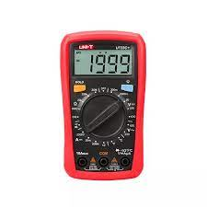

**Theory & Background:**

**In this experiment we have studied about how we can make a circuit on bread board using Dc power supply,resistor,and LED. In order to start the experiment firstly we have to do some theoretical works. Now in this experiment we have to make a circuit diagram to easily understand how to do connections on the board that with which terminal which thing connects.In this experiment with the negative terminal which is connected to the resistor and with the positive terminal we connects bulb so that our circuit is closed and it gives us output.The main reason behind the making of circuit diagram is that we can connect the battery,resistor,and LED easily on breadboard effectively. After making the circuit now its time to calculate the current and voltage with the help of DMM meter and after calculating the current and voltage we put these values on the table and do some theoretical works according to our given procedures.**

**Basic Concept:**

**We must have knowledge about the usage of breadboard that how we can make circuit on the breadboard like how actually the breadboard works.Like horizontal and vertical dots represents the wires so if we want to make a circuit on the Breadboard we must know how to make the complete circuit on breadboard so that at the end our circuit should be closed and we get the output at the end.We must know about the Multi-Meter and how to switch the multi-meter from voltage to current or from current to resistance actually we can calculate the three quantities on the DMM meter like voltage when its connected in the series,or current when connected parallel in the circuit,or resistance.These are the quantities which we can find from the DMM meter.Like wise in this experiment we have make a circuit on breadboard with resistor and LED.So firstly we have connect the power supply with the breadboard horizontally each with next to each other to make polarity at the end of the breadboard.Now with positive terminal we have to connect the LED and on other hand we have connect the resistor with other side of the terminal.We have connect these two in a such way that the circuit should close at the end and we got output from the circuit.**

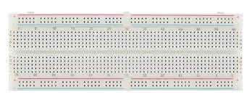

**Fig ; 1.3**

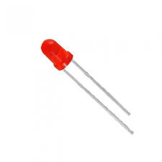

**Fig ; 1.4**

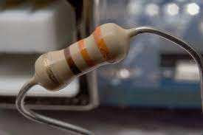

**Fig ;1.5**

**Objective:**

**.At the end of doing this experiment we must be aware about the usage of breadboard, and how to make circuit on the breadboard.**

**.And why circuit is complete on the breadboard even though there is not a single wire which we use.**

**.At the end of experiment we must know about the Galvanometer and though this meter how we convert it into Ammeter and Voltmeter.We must have the concept of Ammeter and Voltmeter and how to install these meter in the circuit .**

**.And what was the need of making Digital Multi-Meter and how to calculate the voltages and currents though this meter and what way to install the DMM for measuring these values.**

**.We also have the concept of Digital Multi Meter and how to use this meter and how to take the readings of Current ,Voltage ,and Resistance.**

**Result & Discussion:**

**.using Breadboard we can make a circuit but we must know how to use the Bread-board that at the end our circuit should be closed and it gives us output at the end of the experiment.**

**.How to use the DMM meter to calculate the voltages and Currents across the circuit.**

**.voltage given by the supply and voltage calculated by the DMM across the LED and Resistor is different and it is due to fact that voltage drops across the LED and Resistor.**

**Task 1: DMM Range Table**:

|  |  |  |  |  |  |
| --- | --- | --- | --- | --- | --- |
| Ranges | DC  Voltage | AC  voltage | DC  Current | AC  Current | Resistance |
| Minimum |  |  |  |  |  |
| Maximum |  |  |  |  |  |

***Table#1: DMM Range***

**Other Function on DMM:**

**Task 2: DC Voltage Measurement Table:**

|  |  |  |  |  |
| --- | --- | --- | --- | --- |
| Sr # | Voltage  (Volts) | Voltage  On  Power supply | Voltage  On  DMM | % Error |
| 1 | 2V |  |  |  |
| 2 | 4V |  |  |  |
| 3 | 6V |  |  |  |
| 4 | 8V |  |  |  |

***Table#2: DC Voltage Measurement***

**Task 3: Current Measurement:**

1. Explain how you can measure a current flow using a DMM. Justify your answer with appropriate reason.

**In order to measure the flow of current in circuit we have to break the circuit first and Then we have to install the DMM meter by setting it on the current measurement on the Bread-board.We have make connection of the Black probe of the DMM meter with the Negative terminal of the battery and red probe with positive terminal of the battery in such a way that DMM meter must connected in series.We must have consideration of Making complete circuit because with out closed circuit it did not gives us output.simply by installing the ammeter in series within the circuit gives us our required reading of Current in circuit.**

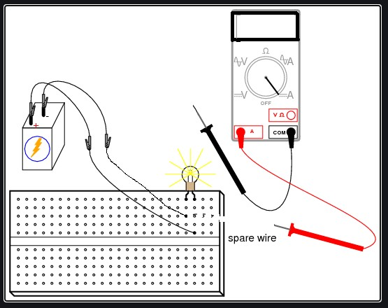

***Fig#2: Complete Circuit***

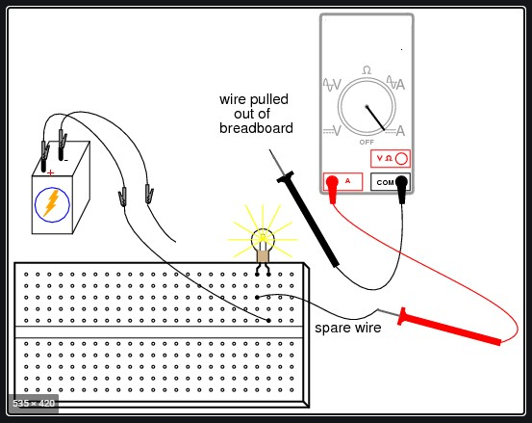

***Fig#3: Wire Pulled out/Circuit breaking is done while measuring Current(I)***

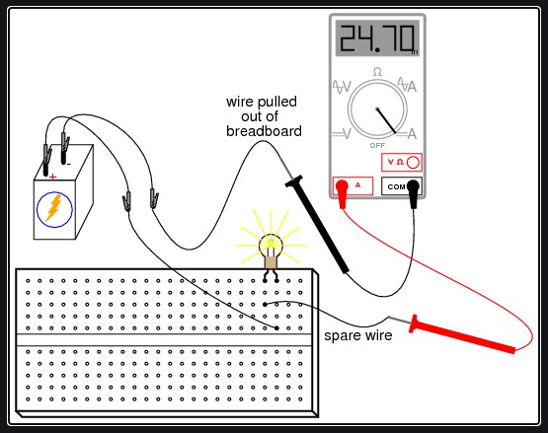

***Fig#4: Current Measuring/Complete Setup***

**Task 4:**

1. Measure the voltage across the resistor and LED in circuit below by using DMM, by assembling the circuit on a bread board when voltage provided by power supply is: V=10V and R=1kΩ

**Now Firstly we have to install the LED and resistor on the Breadboard in that way that our circuit will closed and it gives us output.**

**We have set the power supply on 10V and using Resistor on 1K Ohm.**

**In order to find the voltage across the LED and Resistor we have to install the DMM meter parallel so one terminal of the DMM is connected to the one end of resistor or LED and other terminal with the other terminal of resistor or LED thats how we can calculate the voltage drop across the Resistor and LED.**

**Using this we can calculate the voltages drops across the both Resistor and LED**.

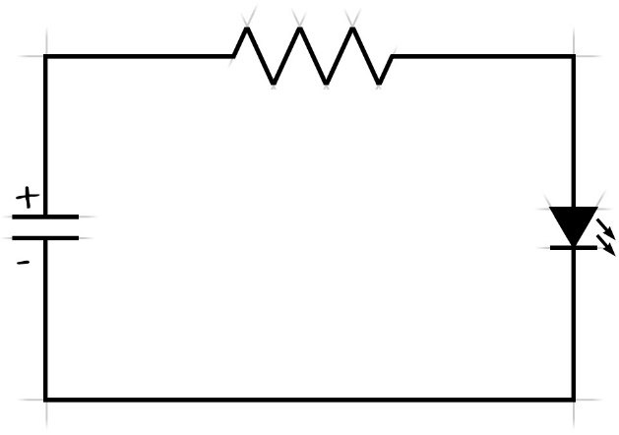

***Fig#5: Voltage Measurement Circuit***

1. Measure the current in the circuit below.

**In order to measure the current in circuit below we have to install the Ammeter in series of the circuit.with black probe of the DMM with the negative terminal of the battery and the red probe with the positive terminal of the battery in this circuit breaking take place so that we can connect the Ammeter in series within the circuit.Note that we have to convert the DMM meter into the Ammeter and then we can calculate the current in the circuit.**

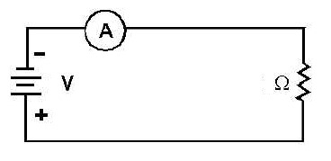

***Fig#6: Current Measurement Circuit***

**Task 5:**

1. Assume that you are expecting a voltage between 13-14 volts. Where the selection knob should be adjusted if options available at 5V, 10V, 15V and 20V? Justify your answer with appropriate reasoning.

**Selection knob should be adjusted on the 15 volts as we know that required voltage should be in between the 13-14 volts so in order for convenience result we have to turned the knob to the 15 volt.Because its give us precise value at the end of the experiment.the uncertainty will be much less than taking other voltages on the supply.Saturation could be occurs with the DMM because if the Voltage is not in range of DMM meter then it might cause saturation like wise using 5 and 10 volts which are too low are not in range of DMM might cause the saturation of DMM and this Saturation damages the DMM and at the end it gives us not convenient result thats why we have taken 15 volt for our experiment.**

**Task 6: Purpose and functions of different Input Jacks on DMM:**

|  |  |  |
| --- | --- | --- |
| **Input Jack** | **Purpose** | **Limits** |
| COM |  |  |
| VΩ |  |  |
| mA |  |  |
| 10 A |  |  |

***Table#3: DMM Jacks***

**Conclusion:**

**At the end of experiment we have learnt how to make circuit on the Breadboard. And with the help of DMM meter how to calculate the voltage and current across the Breadboard.By using different voltages set on the power supply we calculate the the voltage across the circuit.In this experiment we have learnt that how we can install the DMM when it is switch to the Ammeter measurement for that we have to break the circuit and connect the negative probe of the DMM with the negative terminal of the supply and red probe with the other terminal of the battery.**

**Now for measurement we have to switch the DMM to the Volt-meter and as we know that Volt-meter is connected parallel in the circuit.So in order to find the voltage we have to install the DMM across the resistor and LED connected with one terminal and second with the other terminal of Resistor and LED and in this way we can calculate the voltages drops across the Resistor and LED.**

**Then we have noted these values on the table and find our percentage error and also noted those reading on the tables.**

**Reference:**

**Fig ; 1.1**

.[LED circuit schematic | Electronic circuit projects, Electronics logo, Circuit projects](https://www.pinterest.com/pin/led-circuit-schematic--654288652094162454/)

Fig ; 1.2

[UNI-T UT33C+ Palm Size Digital Multimeter DMM](https://www.google.com/url?sa=i&url=https%3A%2F%2Felectrobes.com%2Fproduct%2Funi-t-ut33c-palm-size-digital-multimeter%2F&psig=AOvVaw38-qe3qvjTUp9CW4RpiOlG&ust=1710091135338000&source=images&cd=vfe&opi=89978449&ved=0CBUQjhxqFwoTCMjju4jY54QDFQAAAAAdAAAAABAE)

Fig ; 1.3

[How to Use a Breadboard - SparkFun Learn](https://www.google.com/url?sa=i&url=https%3A%2F%2Flearn.sparkfun.com%2Ftutorials%2Fhow-to-use-a-breadboard%2Fall&psig=AOvVaw3Xgi-9pxe4sLxDuJkMZBUy&ust=1710091221686000&source=images&cd=vfe&opi=89978449&ved=0CBUQjhxqFwoTCICxrLHY54QDFQAAAAAdAAAAABAE)

Fig;1.4

[3mm Red LED In Pakistan | Electronics Hub](https://www.google.com/url?sa=i&url=https%3A%2F%2Felectronicshub.pk%2Fproduct%2F3mm-red-led%2F&psig=AOvVaw25EluM_krtnWdhP1FsvIGu&ust=1710091316541000&source=images&cd=vfe&opi=89978449&ved=0CBUQjhxqFwoTCLiWht_Y54QDFQAAAAAdAAAAABAE)

Fig; 1.5

[Resistor Symbol, working, Color code and Types – Analyse A Meter](https://www.google.com/url?sa=i&url=https%3A%2F%2Fanalyseameter.com%2F2016%2F04%2Fresistor-symbol-working-color-code-and-types.html&psig=AOvVaw2ghqfsp257KpdPdwGhebGC&ust=1710091341952000&source=images&cd=vfe&opi=89978449&ved=0CBUQjhxqFwoTCPDDq-zY54QDFQAAAAAdAAAAABAE)